**DAILY ONLINE ACTIVITIES SUMMARY**

|  |  |  |  |  |  |  |  |
| --- | --- | --- | --- | --- | --- | --- | --- |
| **Date:** | **15/06/2020** | | | | **Name:** | Tushit Shukla | |
| **Sem & Sec** | **4 SEM & B SEC** | | | | **USN:** | **4AL18CS093** | |
| **Online Test Summary** | | | | | | | |
| **Subject** | | - | | | | | |
| **Max. Marks** | | - | | **Score** | | - | |
| **Certification Course Summary** | | | | | | | |
| **Course** | **PYTHON PROGRAMMING** | | | | | | |
| **Certificate Provider** | | | **Great Learning** | **Duration** | | | **1.5 hr(spent by me on that day to learn)** |
| **Coding Challenges** | | | | | | | |
| **Problem Statement:**  1 A string is k palindrome if it can be transformed into a palindrome on removing at most k characters from it. Your task is to complete the function is_k_palin which takes two arguments a string str and a number N . Your function should return true if the string is k palindrome else it should return false.  Input: The first line of input is an integer T denoting the number of test cases . Then T test cases follow . Each test case contains a string str and an integer N separated by space.  Output: The output will be 1 if the string is k palindrome else 0 .  **Example** Input : String - abcdecba, k = 1 Output : Yes String can become palindrome by remo- -ving 1 character i.e. either d or e)  Input : String - abcdeca, K = 2 Output : Yes Can become palindrome by removing 2 characters b and e.  Input : String - acdcb, K = 1 Output : No String can not become palindrome by removing only one character. | | | | | | | |
| **Status: Completed** | | | | | | | |
| **Uploaded the report in Github** | | | | **Yes** | | | |
| **If yes Repository name** | | | | <https://github.com/tushitshukla29/lockdown-program> | | | |
| **Uploaded the report in slack** | | | | **Yes** | | | |

**Online Certification Details**

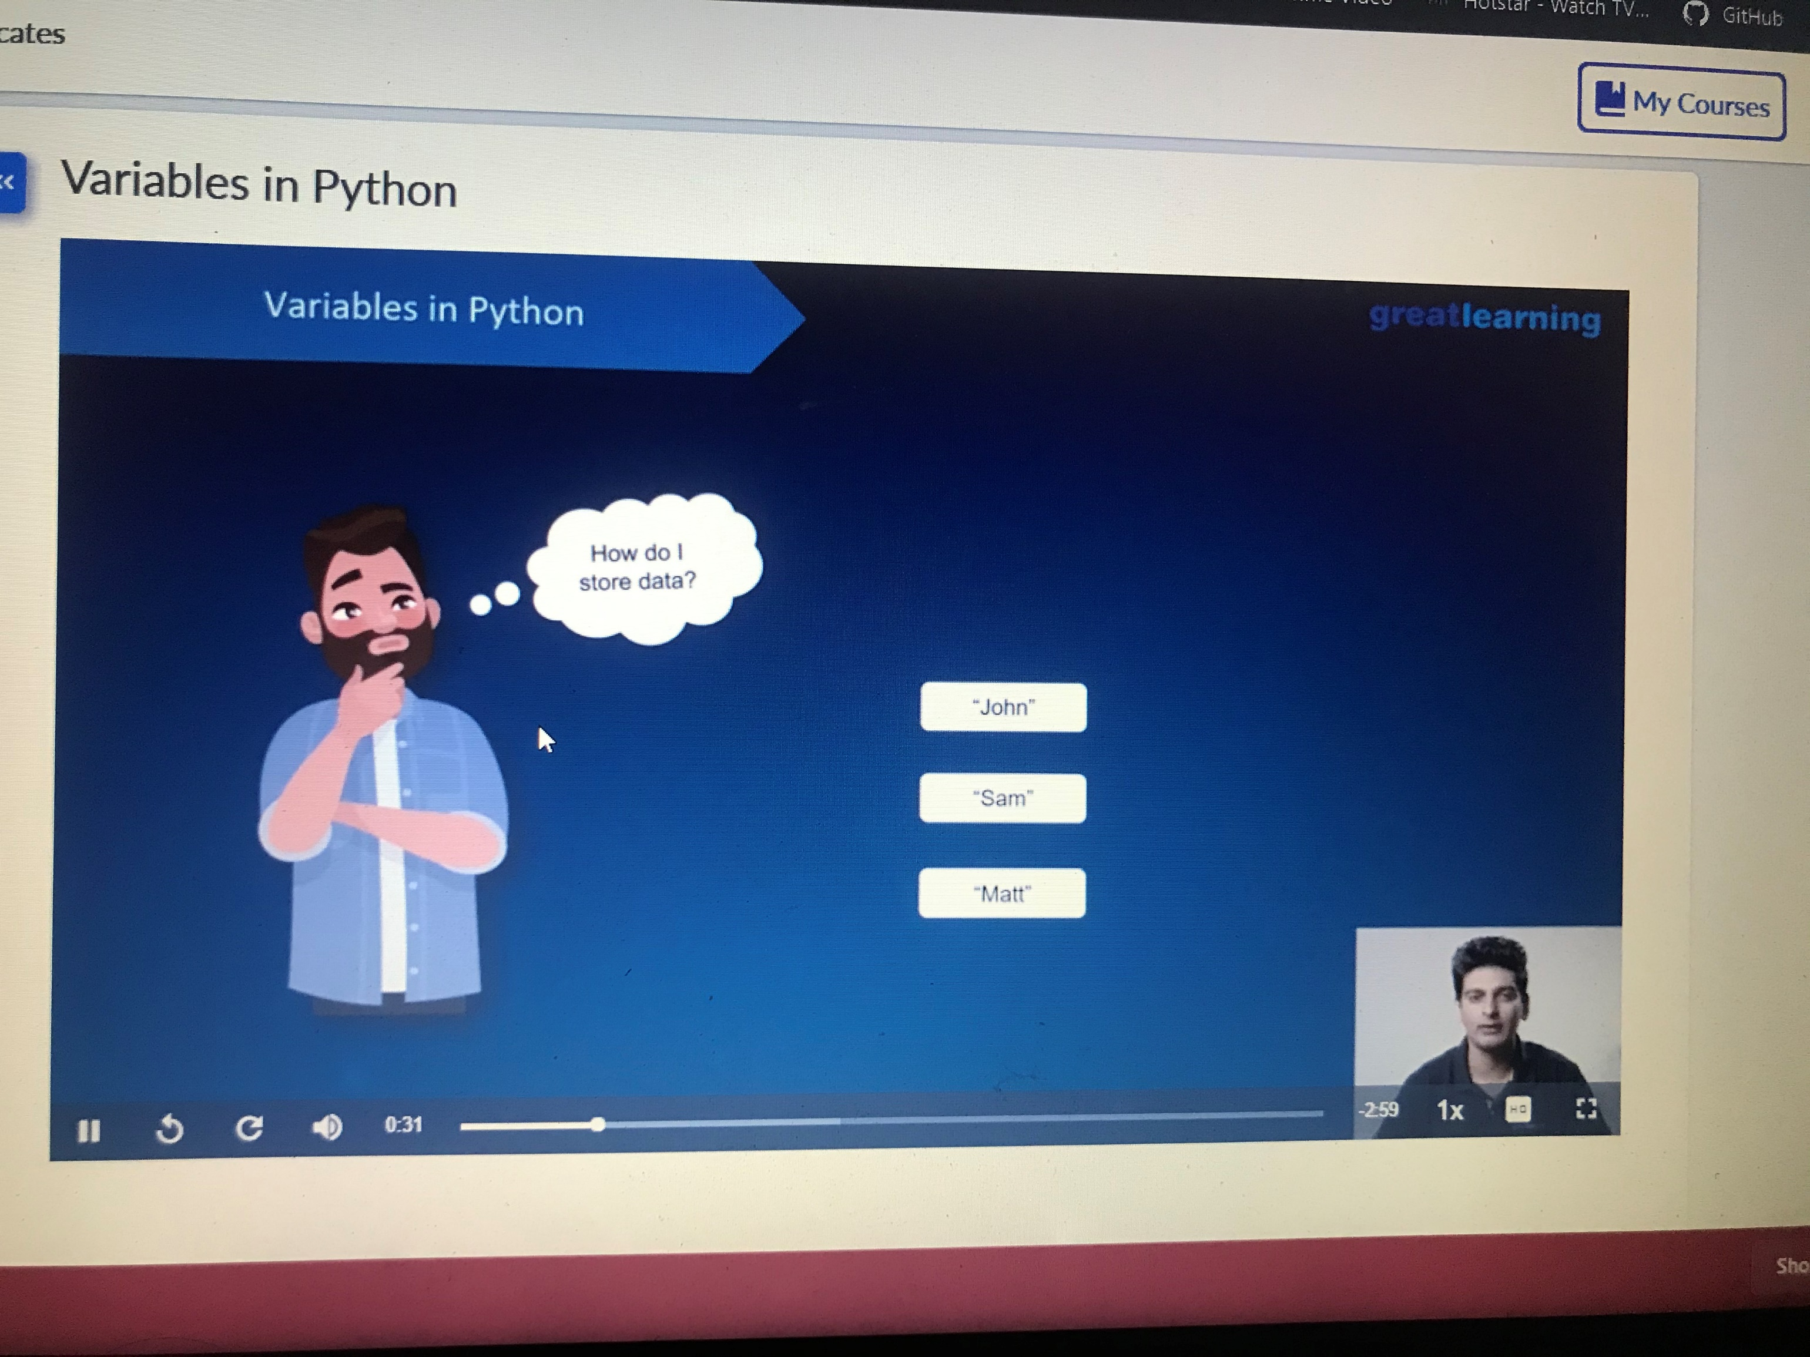

**Coding Challenge Details**

1. <https://github.com/tushitshukla29/lockdown-program/blob/master/Palindrome>